**Demographic research**

Demographic for puzzle/problem solving games

A study of 140,000 people suggests that older gamers prefer strategic games involving careful decision-making and planning when compared to competitive games (Nick Yee, 2016).

42% of Casual Puzzle gamers are female (Nick Yee, 2017).

The appeal of competition declines most with age. Females decline faster than males. The decline is most prominent between ages 13 – 35. (Nick Yee, 2016).

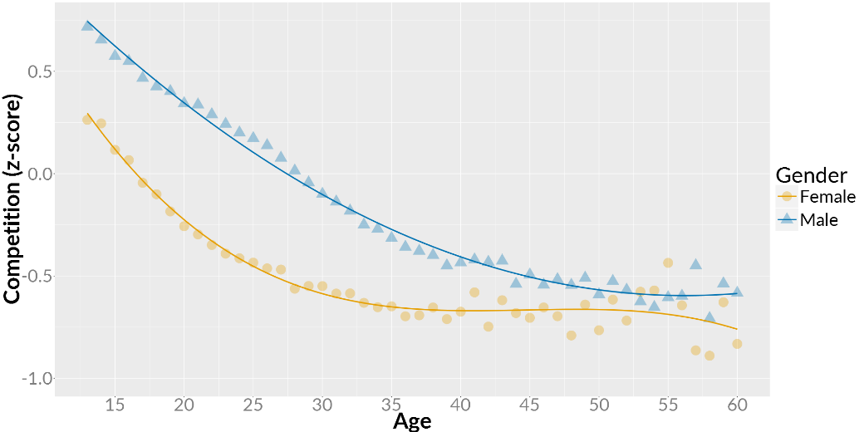

Bibliography

[1] D’Anastasio, C. (2017). *Study Shows Which Video Game Genres Women Play Most* [Online] 20 January 2017. Available online: <https://kotaku.com/study-shows-which-video-game-genres-women-play-most-1791435415> [Date of access: 05 October 2017].

[2] Yee, N. (2017). *Beyond 50/50: Breaking Down The Percentage Of Female Gamers by Genre.* [Online] 19 January 2017. Available online: <https://quanticfoundry.com/2017/01/19/female-gamers-by-genre/> [Date of access: 05 October 2017].

[3] Yee, N. (2016). *As Gamers Age, The Appeal of Competition Drops The Most. Strategy is The Most Age-Stable Motivation.* [Online]. 10 February 2016. Available online: <https://quanticfoundry.com/2016/02/10/gamer-generation/> [Date of access: 05 October 2017].

[4] Yee, N. (2016) *5 Things We Learned About The Appeal of Competition From Over 239,000 Gamers*. [Online] 11 August 2016. Available online: <https://quanticfoundry.com/2016/08/11/appeal-of-competition/> [Date of access: 05 October 2017].

**Other:**

2017 Sales, Demographic and Usage Data. Essential facts about the computer and video game industry. <http://www.theesa.com/wp-content/uploads/2017/04/EF2017_FinalDigital.pdf>